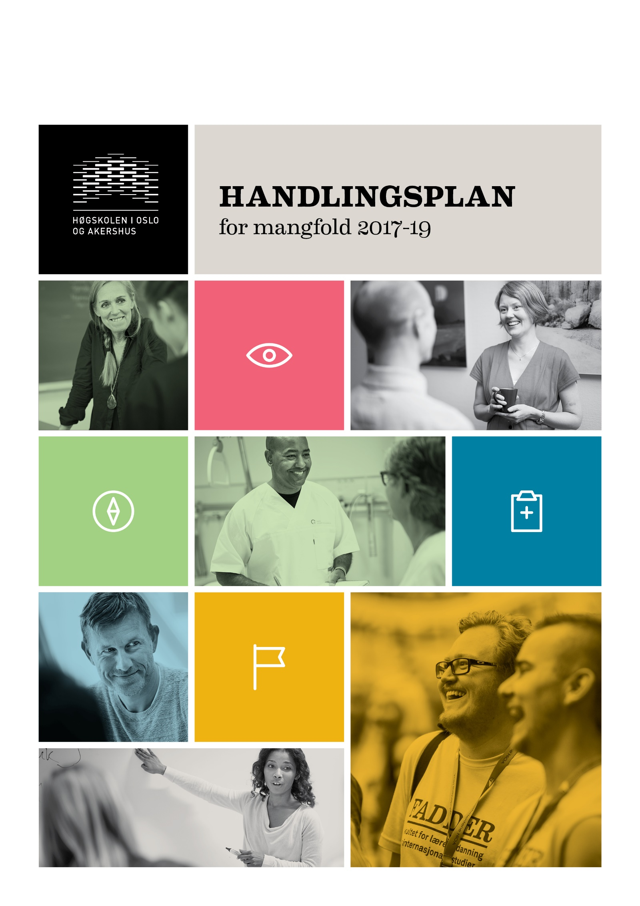
Contents

Summary 3
1. Introduction 6
Strategic basis 6
Goals and target groups 6
From gender equality to diversity 6
Clarification of terms and the structure of the plan 7
2. Current status 9
An organisational culture and a working environment characterised by diversity 9
2.1 Gender 10
Gender balance 10
2.2 Ethnicity 13
2.3 Functional ability 15
Universal design: Physical conditions 15
Universal design: ICT solutions 16
3. Objectives and measures for the coming period (2017–2019) 18

Summary

Strategic basis, objectives and diversity
The work to promote diversity is based on the sector goals defined by the Ministry of Education and Research (KD) and in Oslo and Akershus University College of Applied Sciences' (HiOA) main strategy, Strategy 2020. The objective of this action plan is to create an inclusive working and study environment. Diversity is one of HiOA’s core values, and the institution wants to apply this expanded equality concept. Diversity is considered an important resource at HiOA, and we believe that diversity of background and experience among staff and students is a strength in developing research and education in a society and region that are becoming increasingly diverse.

Current status
The plan provides an overall description of the status/perceived present situation in relation to each of these grounds for discrimination: gender, ethnicity and functional impairment. The decision to limit the plan to these three grounds for discrimination was made because they correspond to the obligations under the institution’s duty to actively promote equality.

- Gender: It is a goal for HiOA to have good gender balance both in teaching and research (TR) positions and in technical and administrative (TA) positions, as well as in the student body. HiOA has a very good gender balance in top academic positions, with 47.4% women and 52.6% men. Women account for 66.3% of total full-time equivalents, while 69.9% of HiOA’s students are female.

Male and female staff at HiOA shall receive equal pay for equal work or work of equal value. The pay statistics show that there are no systematic differences in the average pay between men and women at HiOA. Wage developments are monitored through local wage negotiations and the Rector’s negotiation authorisation.

- Ethnicity: HiOA wants to reflect the population of the Oslo and Akershus region and its ethnic diversity. Moreover, the ambition to become a university and HiOA’s internationalisation strategy mean that the institution has to assert itself in the fields of international recruitment and mobility. HiOA became Charter and Code certified in 2016. This certification is intended to facilitate mobility to and from HiOA and entitles the institution to use the European Commission’s HR Excellence in Research logo.
The university and university college sector, including HiOA, does not have any systematic information about employees with immigrant backgrounds. This was the reason why the Nordic Institute for Studies in Innovation, Research and Education's (NIFU) and Statistics Norway prepared diversity statistics in 2016 to show the proportion of immigrants and descendants of immigrants in research and higher education in Norway. These statistics can form a basis for a future systematic mapping of the status and development of measures in relation to ethnicity as grounds for discrimination.

- Functional ability: HiOA provides 1) physical and 2) organisational and work environment adaptation for employees with functional impairments. The statement on diversity that is included in all job advertisements offers workplace adaptation as necessary. In 2016, HiOA drew up a local Inclusive Workplace (IW) agreement intended to ensure that the revised IW Agreement is followed up, including its Operative goal 2: Prevent withdrawal and increase employment of people with reduced functional ability. The students have their own adaptation service. In order to guarantee equal right to education, the requirements for universal design of IT solutions will become more stringent in future. Universal design shall be implemented in IT solutions in the education sector by 1 January 2021.
Objectives and measures
The action plan is not organised by grounds for discrimination but by areas of activity, as it is desirable for HiOA to have an integrated diversity policy. However, what is known as mainstreaming is not effective without institutionalisation, concrete strategies and assignment of responsibility. The action plan as adopted by the Board shall therefore oblige the institution to apply a diversity policy where responsibility is not diffused, but assigned, and where concrete measures are to be implemented by a stipulated deadline. The measures are organised in three main groups with associated main goals. A complete overview of measures can be found on pages 15–17.

- Institution level – organisation and management
Main goal: HiOA’s core value diversity shall be an integral part of the institution's culture, structure and management.

- Faculty and centre level – research and education
Main goal: The faculties shall apply an effective local diversity policy, and relevant diversity perspectives shall be integrated into research and development.

- Recruitment and development
Main goal: HiOA’s recruitment and career development processes shall be characterised by equal opportunities. Career and competence development measures shall contribute to raising the organisation's diversity competence.
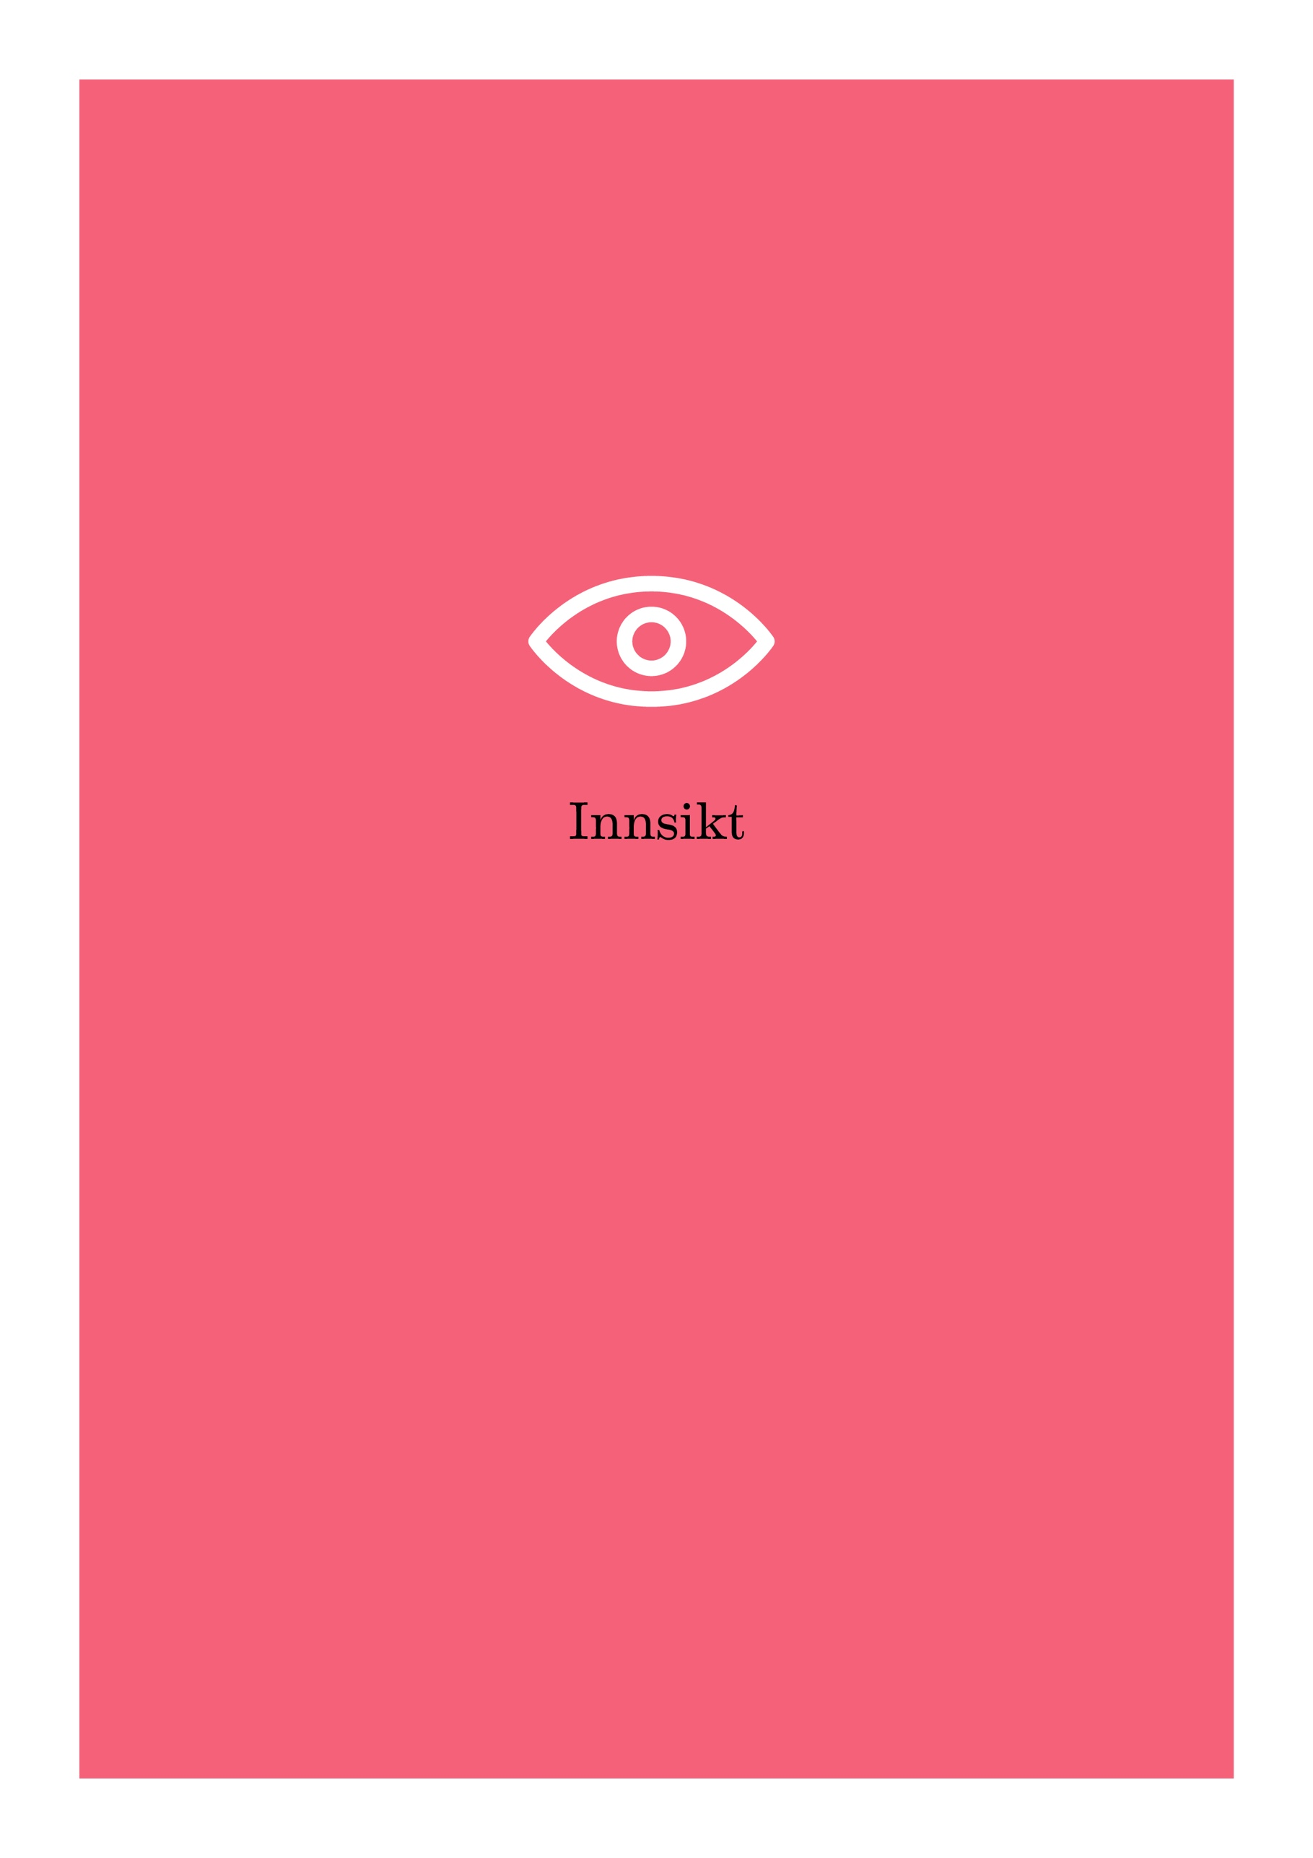

Introduction

Strategic basis
The work to promote diversity is based on the sector goals defined by the Ministry of Education and Research (KD) and in Oslo and Akershus University College of Applied Sciences' (HiOA) main strategy: 'HiOA is a metropolitan institution, located in a region whose demographic structure is more diverse than in other regions in Norway. This diversity gives us an advantage in terms of understanding and reaping the benefits of diversity. We must stimulate equality and demand tolerance of other people's beliefs and life philosophy, cultural background and gender.’ In 2016, the university college's Board decided for the first time to allocate earmarked strategy funds to the institution’s efforts to promote diversity, thereby further consolidating these efforts.

Goals and target groups
The objective of this action plan is to create an inclusive working environment by promoting diversity and preventing discrimination in the workplace at HiOA. As an employer, HiOA has a duty to make active, targeted and systematic efforts to this end. In addition to complying with the requirements of the law, it is deemed important and right to have a personnel policy that helps us to recruit the best minds, brings out the best in the university college's employees and ensures equal rights for all employees. It is both about fairness and about investing in getting the most out of the employees' resources. This action plan is intended to serve as a concrete tool in the active efforts to achieve an inclusive and fair personnel policy. The target group for this action plan is therefore HiOA's employees.

This action plan introduces a change in that the goals and target group are partly expanded to include students. HiOA is geographically located in Norway’s most diverse region and considers it part of its social mission to have an organisational culture and a working and study environment that reflect this diversity. This responsibility includes both educating graduates who can respond to diversity in workplaces and society at large by practising equality and being a safe and inclusive place to study.

From gender equality to diversity
Diversity is one of HiOA’s core values, and the institution wants to apply this expanded equality concept. Equality has traditionally been about gender equality to guarantee women and men equal rights, responsibilities and opportunities for education, work, and professional and personal development. Gender is only one of several inequality dimensions in society, however. It is about acknowledging that both prejudices and barriers can be complex, and thus also about developing measures that take account of this complexity. In this way, we take an intersectional approach to our work on equality. Diversity is considered an important resource at HiOA, and we believe that diversity of background and experience among staff and students is a strength in developing research and education in a society and region that are becoming increasingly diverse.

Clarification of terms and the structure of the plan
The plan will give a general description of the current situation as regards gender, ethnicity and functional impairment, and describe the current diversity status of HiOA’s organisational culture, working and study environment. The decision to limit the plan to these three grounds for discrimination was made because they correspond to the obligations under the institution’s duty to actively promote equality. The subsequent section on measures is not organised by grounds for discrimination but by areas of activity, since it is desirable to establish a diversity policy that is an integral part of HiOA’s structures and processes, and not just an appendage. Moreover, this way of organising the measures takes account of the intersectional dimension of work on discrimination and inclusion. The overall goal is for the organisation's culture and structure to be arranged in such a way as to allow HiOA to ‘reap the benefits of diversity’ (Strategy 2020).

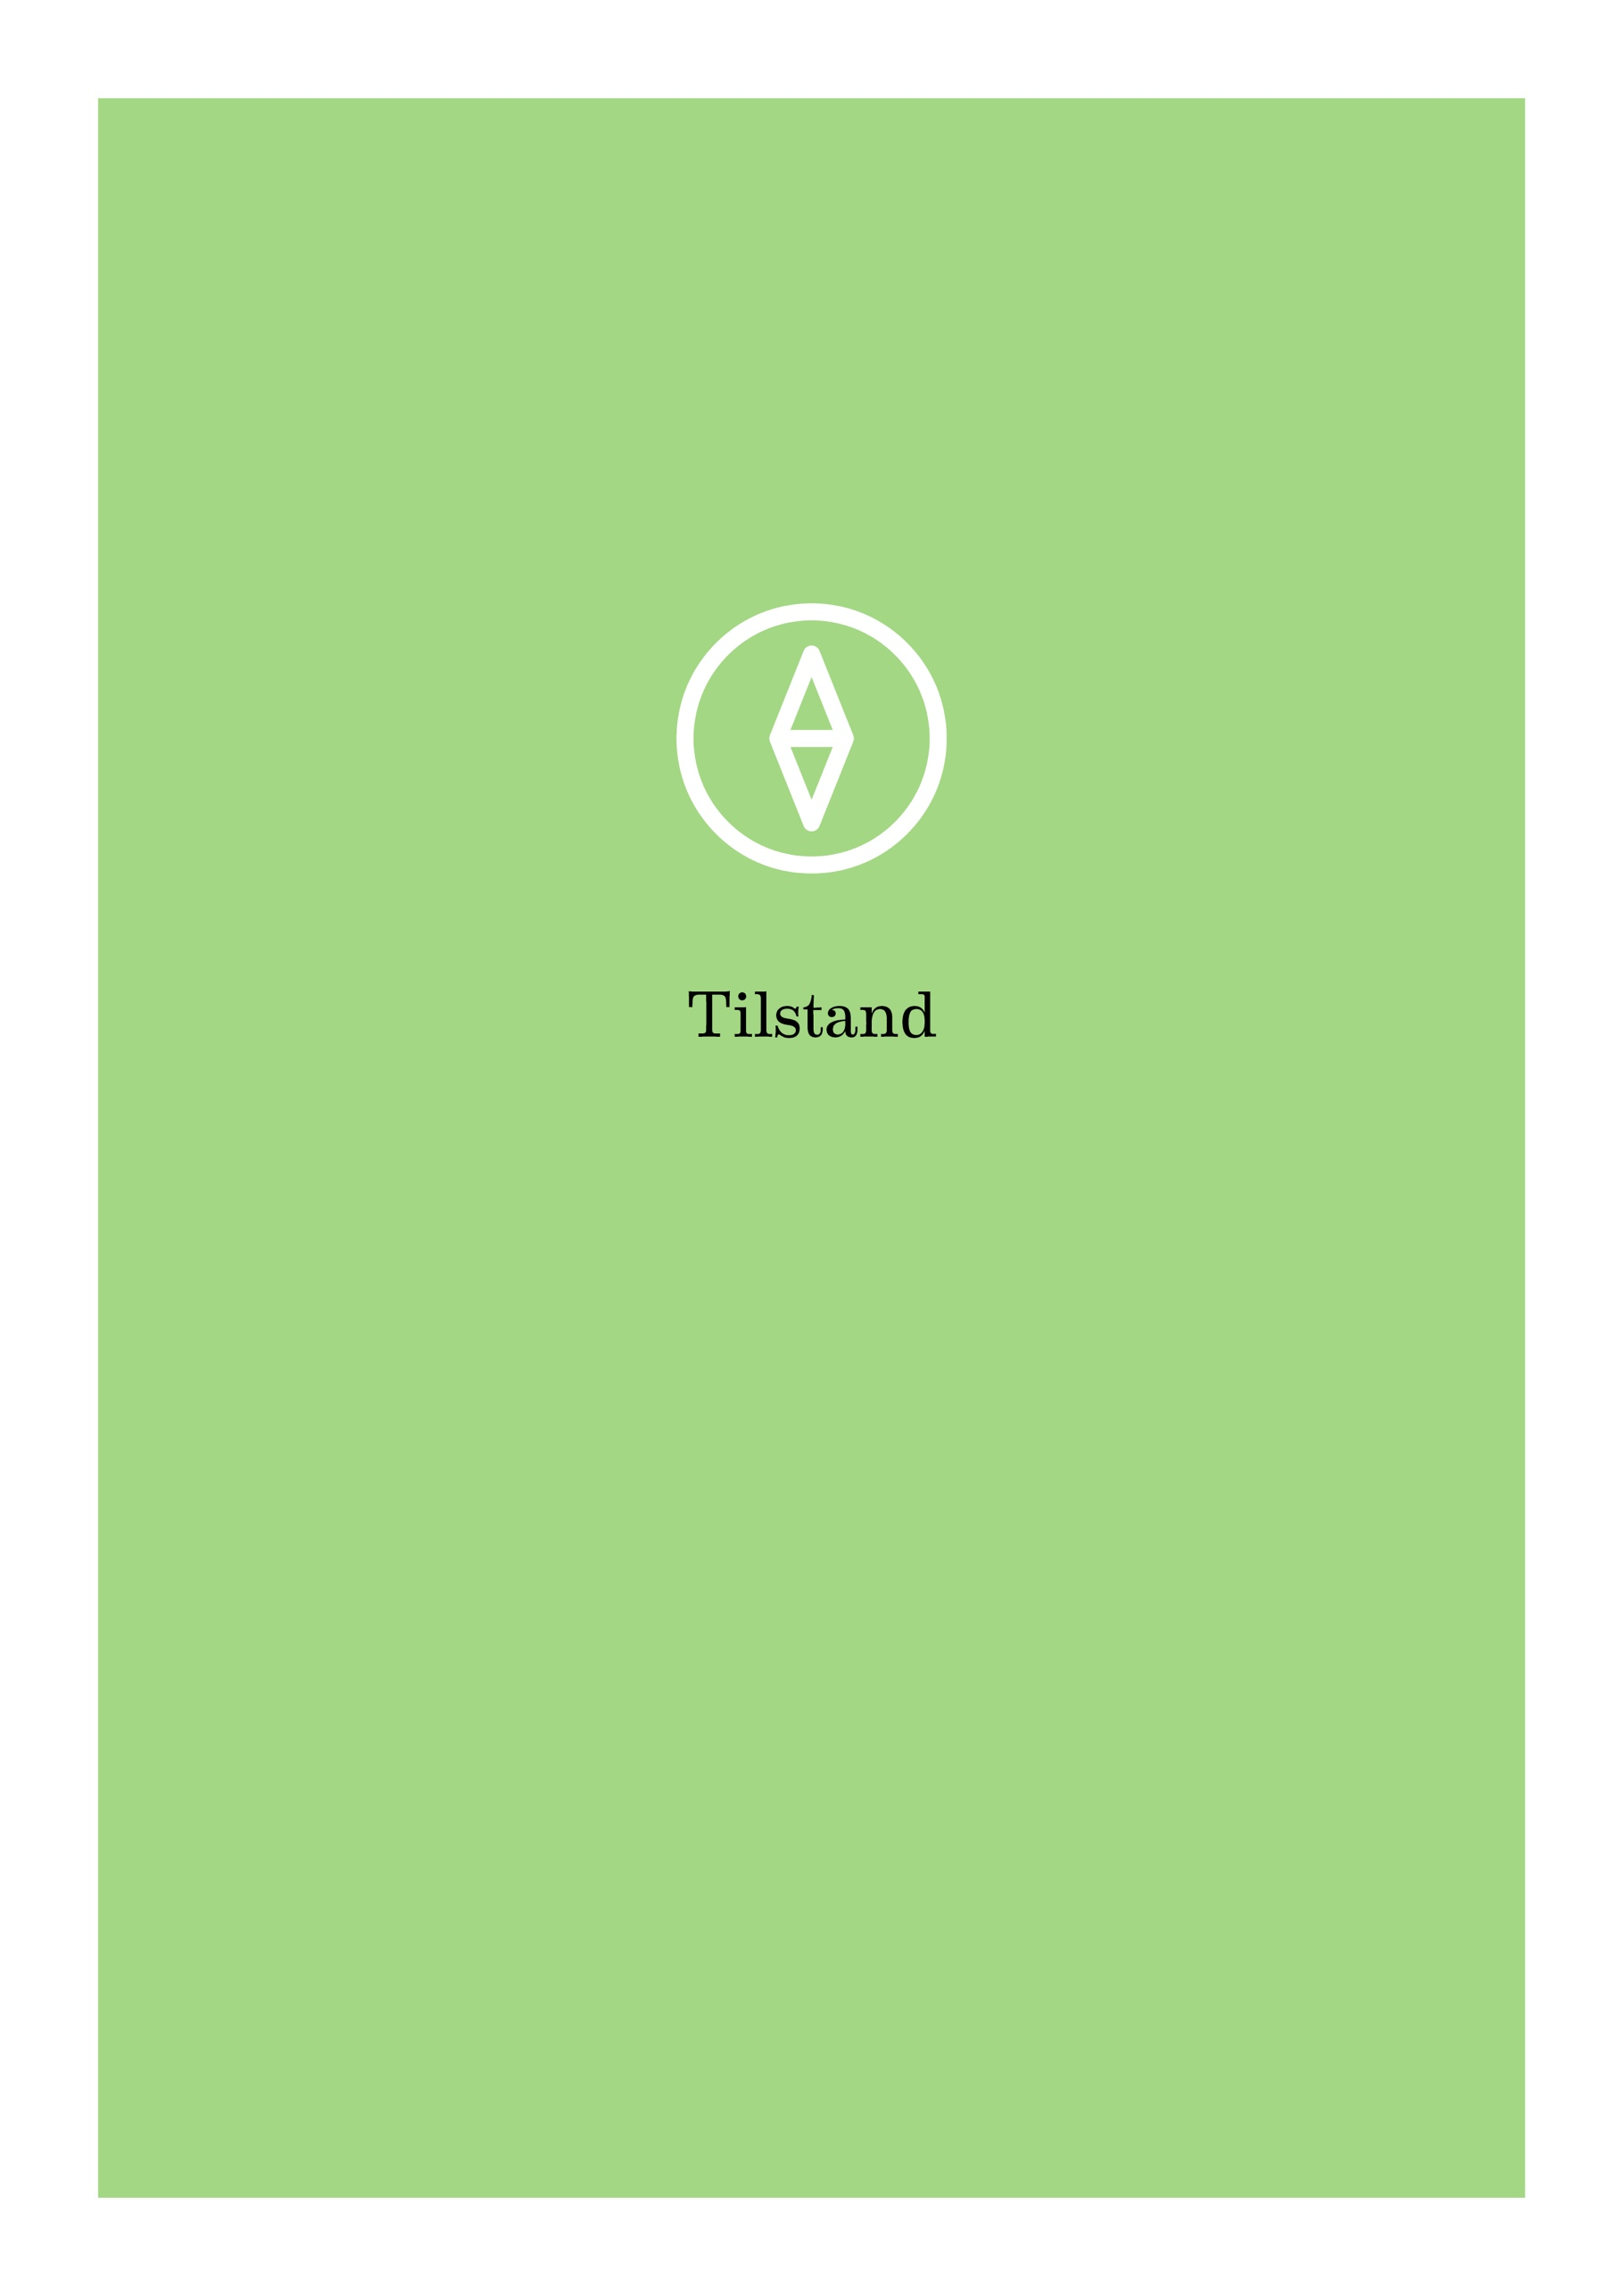

Current status
The main challenge relating to mapping current status and thereby also identifying challenges relating to all grounds for discrimination, with the exception of gender, is that the data are limited or non-existent. Statistics cannot and should not be complied for all possible grounds for discrimination. However, this also limits the possibility to monitor developments and set target figures. In these areas we therefore have to take as our point of departure the perceived status or a wish to develop an organisational culture and a working and study environment characterised by diversity regardless of the measured status.
Below is a brief description of different activities that together contribute to HiOA’s working environment and organisational culture being characterised by our core value diversity. We will then review selected status indicators for gender, ethnicity and functional ability as grounds for discrimination.

An organisational culture and a working environment characterised by diversity
HiOA shall have an organisational culture and a working and study environment characterised by diversity. Different measures and initiatives underpin this goal:
The HiOA Academy, HiOA’s career and competence development provider for all employees, was relaunched in autumn 2016 with diversity as one of its most important strategic focus areas. The Academy offers a variety of courses and training measures for defined target groups to raise employee's diversity competence on topic such as:
- Recruiting diversity – which recruitment procedures promote and inhibit diversity?
- Implicit prejudice as an obstacle to diversity in the workplace
- Rosa kompetanse (‘Pink competence’) – how to behave in a secure and inclusive manner in the workplace in relation to sexual orientation and gender identity
- Organisational culture and diversity
- Universal ICT design
HiOA's culture committee ensures that the institution's core value of diversity is reflected in the cultural events organised for students as well as staff. It hosts queer lunches, feminist literature events, international women's day events etc. In 2017, HiOA will become the first Norwegian institution of higher education to become a Pride Partner, which entails visible support at institutional level for sexual diversity. HiOA will also be hosting the national networking conference for diversity in the university and university college sector in April 2017. The conference will focus on the expanded concept of diversity and how it can be incorporated into organisation and management work in Norwegian academia.
The core value diversity is presented to all new members of staff during their introduction days at HiOA, and the working environment committee (AMU) and the formalised cooperation between the social partners (the information, discussion and negotiations cooperation, IDF) receive regular updates on the status of work on equality and has the opportunity to influence this work. HiOA has a diversity committee comprising representatives of all the faculties and centres, the students and the administration. The committee meets between four and six times a year and acts as an advisory body in matters concerning diversity and equality.
Together, these measures help to create and maintain an organisational culture and a university college environment characterised by diversity. The chief responsibility for coordinating, planning and implementing the environmental and cultural measures rests with the position of programme director for culture, diversity and welfare, which is organised as part of the joint administration (FA).

2.1 Gender
Gender equality has mainly been linked to lack of equality for women, but men can also be victims of gender discrimination. It is a goal for HiOA to have good gender balance both in teaching and research (TR) positions and in technical and administrative (TA) positions, as well as in the student body. HiOA shall provide equal opportunities for work and development and ensure that varied experience and relevant gender theory perspectives are reflected in teaching and research as well as in the study and working environment.

Gender balance
Oslo and Akershus University College of Applied Sciences has a very good gender balance in top academic positions, with 47.4% women and 52.6% men. This is the most balanced proportion in the university and university college sector, and the institution is close to reaching the goal of having a fifty-fifty distribution. In comparison, the average percentage of female professors at the other universities and university colleges in Norway was 26.7% in 2015.

Position categories, HiOA as a whole | Year | Full-time equivalents (Source: DBH)
 |  | no of women | no of men | % women | % men
Professor, dosent professor  and senior researcher | 2016 | 75.25 | 83.51 | 47.40% | 52.60%
 | 2015 | 68.25 | 71.37 | 48.88% | 51.12%
 | 2014 | 56.30 | 69.32 | 44.82% | 55.18%
 | 2013 | 38.90 | 57.67 | 40.28% | 59.72%
 | 2012 | 37.60 | 58.80 | 39.00% | 61.00%

The gender ratios broken down by faculty/joint administration (FA) and centre level show an unequal distribution of top positions at the Centre for the Study of Professions (SPS)/FA and at the Faculty of Technology, Art and Design (TKD). The Centre for Welfare and Labour Research (SVA) and the Faculty of Health Science (HF) has a slight predominance of women in top positions, while the Faculty of Social Sciences (SAM) and the Faculty of Education and International Studies (LUI) has a slight predominance of men in top academic positions.

Professor, dosent professor and senior researcher, 2016 | Full-time equivalents (Source: DBH)
 | no of women | no of men | % women | % men
HiOA, total | 75.25 | 83.51 | 47.40% | 52.60%
FA and SPS | 4.00 | 10.00 | 35.00% | 65.00%
HF | 16.40 | 14.05 | 53.86% | 46.14%
LUI | 14.85 | 15.85 | 48.37% | 51.63%
SAM | 13.80 | 15.30 | 47.42% | 52.68%
TKD | 6.00 | 11.70 | 33.90% | 66.10%
SVA | 20.20 | 16.61 | 54.88% | 45.12%

Development in gender balance from recruitment positions to top teaching and research positions at HiOA
 | Percentage of women in whole numbers (Source: DBH)
Positions | 2012 | 2013 | 2014 | 2015 | 2016
Professors | 41% | 42% | 47% | 49% | 48%
Dosent professors | 27% | 22% | 19% | 43% | 34%
Senior researchers | 0% | 0% | 52% | 55% | 54%
Associate professors (Førsteamanuensis) | 57% | 58% | 59% | 60% | 61%
Associate professors (Førstelektor) | 72% | 71% | 73% | 76% | 78%
Assistant professors | 74% | 75% | 76% | 74% | 76%
PhD research fellows | 79% | 73% | 68% | 70% | 68%
Deans | 25% | 25% | 25% | 0% | 40%
Heads of department | 65% | 68% | 67% | 55% | 60%
Programme coordinators | 80% | 84% | 77% | 77% | 75%
Heads of administrative departments | 60% | 58% | 57% | 67% | 67%
Heads of section | 68% | 64% | 71% | 64% | 65%
Senior advisers | 74% | 75% | 71% | 70% | 68%
Advisers | 69% | 68% | 68% | 71% | 72%
Executive officers | 79% | 73% | 78% | 42% | 67%
Senior clerical officers | 0% | 0% | 100% | 100% | 54%

The gender balance has remained relatively stable over the past five years for all teaching and research (TR) job categories with the exception of dosent professors. The dramatic change in this category from 2014 to 2015 can be explained by the fact that this is a relatively small group, so that small changes account for big percentages. The gender balance in PhD research fellowships has improved somewhat, but this development is not reflected in the top academic positions. We also see that women are overrepresented in job categories that do not require a PhD, except for dosent professor positions. The latter shows a positive development, but active efforts can still be made to encourage women to apply for promotion from associate professor to dosent professor.

The situation for academic administrative positions is similar to that for TR positions, with a predominance of women at lower levels, while women are under-represented at the top level. The gender balance is also skewed for TR positions, with a clear predominance of women. Here we see the same imbalance from recruitment to top positions, however.

Women account for 66.3% of the total number of full-time equivalents. There is also gender imbalance in the student body, with 69.9% women (HiOA’s annual report, 2015). It is a goal for HiOA to have a good gender balance in all job categories and in the student body. HiOA’s expanded recruitment team therefore reviewed the recruitment procedures during the last plan period in order to identify challenges relating to gender balance, among other things. The Department of Human Resources has also received training in recruiting diversity. Various measures are also implemented by the faculties to counteract gender imbalance at programme level, but the overall impression is that it is difficult to measure the direct effect of these measures.

HiOA’s senior management team (comprising the rector, prorectors, deans, heads of centres, two administrative directors and the head of the Student Parliament) consists of eight men and four women. Of the persons recruited to the top management team during the current rector’s period in office, half have been men and half women.
Gender and pay

The overall average pay is slightly higher for men than for women. In the period 2012–2016, men on average earned marginally more than women in TA positions, while women in TR positions on average earn about 95% of men's average pay in similar positions.

Job categories | Year | Average pay |  | Women's pay as % of men's pay
 |  | Women | Men
Total number of employees | 2016 | 579,003 | 598,733 | 96.7%
 | 2015 | 561,161 | 580,455 | 96.7%
 | 2014 | 560,580 | 583,546 | 96.1%
 | 2013 | 530,713 | 551,918 | 96.2%
 | 2012 | 512,629 | 538,516 | 95.2%
TA positions – total | 2016 | 542,839 | 545,241 | 99.6%
 | 2015 | 524,475 | 521,815 | 100.5%
 | 2014 | 520,600 | 530,546 | 98.1%
 | 2013 | 489,673 | 494,534 | 99.0%
 | 2012 | 469,124 | 481,285 | 97.5%
TR positions – total | 2016 | 598,633 | 626,422 | 95.6%
 | 2015 | 581,731 | 612,085 | 95.0%
 | 2014 | 582,603 | 612,244 | 95.2%
 | 2013 | 553,789 | 582,625 | 95.1%
 | 2012 | 539,333 | 571,311 | 94.4%
Source: SAP
In 2016, women on average earned a little more than men in the job categories programme coordinators, associate professors (førstelektor), assistant professors, heads of department, heads of section and PhD research fellows (see Appendix 4). The pay statistics show that there are no systematic differences in the average pay between men and women at HiOA. Wage developments broken down by gender are monitored through local pay negotiations, and the Board of HiOA made a decision in autumn 2016 to specify in the Rector’s negotiation authorisation that particular attention shall be given to any differences in pay that could be explained by gender. Male and female staff at HiOA shall receive equal pay for equal work or work of equal value.

2.2 Ethnicity
Ethnicity refers to the identification of groups distinguished by differences in origin and culture. It is about socially relevant differences, where the perception of origin and differences may also be key factors, and which it may be difficult to operationalise and apply in policy development.

Terms used
In HiOA's preparation of a diversity action plan, it can be challenging to choose words and terms that are as precise and accurate as possible without creating distance and a feeling of exclusion. The term ethnicity is often used to denote a social category based on national origin, descent, skin colour, language, religion, or a combination of these factors. In Norway, we usually distinguish between indigenous peoples, national minorities, immigrants and children of immigrants. These categories do not encompass all forms of ethnic diversity. This action plan aims to contribute to inclusion and combat all forms of unjustified differential treatment on grounds of ethnicity. This means both being aware of this factor in connection with appointment processes and increasing knowledge in this field among our students. We also see a need to set ourselves concrete quantified targets and monitor developments in relation to these targets. Based on the data available, these targets will be set in relation to immigrants and children of immigrants as this group is defined in the Nordic Institute for Studies in Innovation, Research and Education's (NIFU) diversity statistics (cf. NIFU’s working memo 2016:10).

Definition of ‘people from immigrant backgrounds’
People from immigrant backgrounds includes both 'immigrants', people with two foreign-born parents who have immigrated themselves, and 'Norwegian-born persons to immigrant parents', i.e. people who were born and grew up in Norway who have two foreign-born parents. People from non-Western backgrounds are at particular risk of facing challenges because of their ethnicity. HiOA therefore has a particular responsibility for its students and employees in this group. During the work on this plan, the Faculty of Health Sciences (HF) pointed out that particular attention should be given to the increase in immigration from countries outside the EEA. Is this a group with a particular need for language tuition? What formal competence do they have from their country of origin, and can HiOA make their transition into the labour market easier by offering complementary education programmes? It is proposed that these questions should be addressed in local faculty action plans based on a common template developed by the central HR department. The local action plans should be linked to the interfaculty institution plan.

NIFU’s statistics do not distinguish between immigrants or their descendants who have taken their whole education in Norway and those who arrive through international recruitment. The latter group is growing at HiOA as a result of, among other things, the institution's internationalisation strategy and its ambition to achieve university status.

Employees from immigrant backgrounds in Norwegian research and higher education
At present, HiOA does not have any systematic information about employees from immigrant or foreign backgrounds. HiOA is not unique in this respect. There are no systematic statistics of immigrant employees in the university, university college and institute sector in general. The available statistics are mostly studies that provide a snapshot of the situation at a particular time, and there are few time series that show development trends. This was the reason why the Nordic Institute for Studies in Innovation, Research and Education (NIFU) and Statistics Norway prepared diversity statistics in 2016 to show the proportion of immigrants and descendants of immigrants in research and higher education in Norway. These statistics were prepared on assignment from the Ministry of Education and Research following input from the Committee for Gender Balance and Diversity in Research, and is a follow-up study to the qualitative HiOA/NIFU report Being a foreigner is no advantage (2016).

The statistics show that that the proportion of immigrants and descendants of immigrants in Norwegian research is 25%, while the proportion at HiOA is 13% (2014). On average, the universities do better than the university colleges in these statistics. Given HiOA’ internationalisation strategy, its ambition to become Norway’s next university and the growing immigrant population in Oslo and Akershus counties, HiOA should look behind this figure to find the reasons why it is so low compared with institutions with which we should compare ourselves. Both of HiOA's research centres, SVA and SPS, have researchers that address different challenges relating to recruiting diversity to programmes of professional study: Which programmes have a diverse recruitment base, and which ones are ethnically homogenously Norwegian? What distinguishes HiOA from other educational institutions? What can we do to recruit more people from immigrant backgrounds to ‘middle-class professions’ and not ‘just’ to ‘elite professions’ (such as doctor, engineer and lawyer)? Knowledge about this will enable us to implement effective measures, and it is recommended that our own expert environments be involved in exploring these issues. For HiOA, it is also relevant that about four out of ten immigrants and Norwegian-born persons with immigrant parents, a total of 39.5%, live in Oslo and Akershus counties (2013). The wish to reflect this percentage is expressed in HiOA’s declaration of diversity, which is included in all job advertisements:
It is important to HiOA to reflect the population of our region, and all qualified candidates are welcome to apply. We make active efforts to further develop as an inclusive workplace and to adapt the workplace if required.

Charter and code
International recruitment is a constantly developing focus area at HiOA. In 2016, HiOA was Charter and Code certified, which means that it is one of the few Scandinavian institutions of higher education that meet the criteria for using the European Commission’s HR Excellence in Research logo. This certification is intended to facilitate mobility to and from HiOA. Charter and Code for Researchers is a European framework (EU) that puts work to promote gender balance and diversity on the agenda.
Academic Dugnad for Refugees
Since 2015, the international diversity work has included HiOA's involvement in the Academic Dugnad for Refugees. Many asylum seekers and refugees who arrive in Norway have completed higher education, are researchers or were students when they were forced to leave their home country. The university and university college sector wishes to show solidarity with refugees in a difficult situation. HiOA organises various events and activities for and with refugees and asylum seekers as part of the Academic Dugnad initiative.

2.3 Functional ability
A functional impairment exists when a person has suffered loss of, damage to or some other form of impairment of one of the body's physical, mental or cognitive functions. This does not necessarily mean that the person's capacity for work is impaired.

Adaptation measures
Adaptation measures for employees with functional impairments are often divided into the following categories:
1) Physical adaptation
2) Organisational and working environment adaptation

See Appendix 2 for a complete overview of HiOA’s adaptation measures. Overall institutional responsibility for adaptation for employees with functional impairments lies with the university college's joint administration and with the HR, Facilities Management, ICT and Finance departments in particular. It is, however, vital that the joint administration has a close, good dialogue with the faculties and centres in order to ensure expedient agreement between status and measures.

Local IW agreement
Discrimination based on functional impairment is generally due to poor adaptation or stereotypical perceptions of the practical consequences of having a functional impairment. Sixty-eight per cent of people with a functional impairment who have a university or university college education are in employment, compared to 92 per cent in the rest of the population. Addressing this difference is in line with the revised Inclusive Workplace (IW) Agreement's special focus on increasing labour market participation among people with functional impairments. HiOA is an IW enterprise and is committed to following up this objective. In 2016, HiOA drew up a local IW agreement intended to ensure that the revised IW Agreement is followed up, including its Operative goal 2: Prevent withdrawal and increase employment of people with reduced functional ability. See the local action plan in Appendix 3.

The degree of functional impairment is related to the degree of universal design and individual adaptation of the surroundings. The Anti-Discrimination and Accessibility Act defines universal design to mean designing or accommodating the main solution as regards physical conditions, including information and communication technology (ICT), so that they can be used by as many people as possible.

Universal design: Physical conditions
In order to ensure that these statutory duties are followed up properly, the Department of Facilities Management earmarked funds for universal design measures for the first time in 2016 and plan to continue to do so in future budgets. Measures relating to impaired mobility, visual and hearing impairments will be given priority. In connection with new rehabilitation projects, universal design will be an integral element of the building case on a par with fire protection, indoor climate, acoustics, access control etc. As regards existing premises, measures will be implemented on a continuous basis based on needs reporting from the adaptation service or the HR departments. The Department of Facilities Management and Universell, the national coordination body appointed by the Ministry of Education and Research, will hold a national seminar on 1 June 2017 for the network working on universal design of buildings and outdoor areas in the university and university college sector.

Universal design: ICT solutions
Developing ICT solutions, electronic documents and forms that everyone can use is important in order to ensure equal opportunities for education, work and participation in society in general. HiOA’s career and competence development academy, the HiOA Academy, therefore introduced universal ICT design training in autumn 2016. This training targets employees in both TA and TR positions.
Universal design (statutory requirement WCAG 2.0 AA) is included in all requirements specifications for projects online. HiOA does not approve any solutions unless the statutory requirement for universal design is met. Universal design checks are part of all the platforms’ online operating tasks.

More stringent universal design regulations in the education sector
The requirements relating to universal design of ICT solutions in the training and education sector will become more stringent in future. The Government intends to amend the regulatory framework to make universal ICT design a requirement. The Government’s decision means that the existing ICT solutions in the training and education sector must comply with universal design requirements by 1 January 2021. The Department of Computer Science at HiOA’s Faculty of Technology, Art and Design is home to Norway’s top expert community in the field of universal ICT design. This expert community can and should be a resource in the work to ensure that HiOA complies with the statutory requirements by 2021.

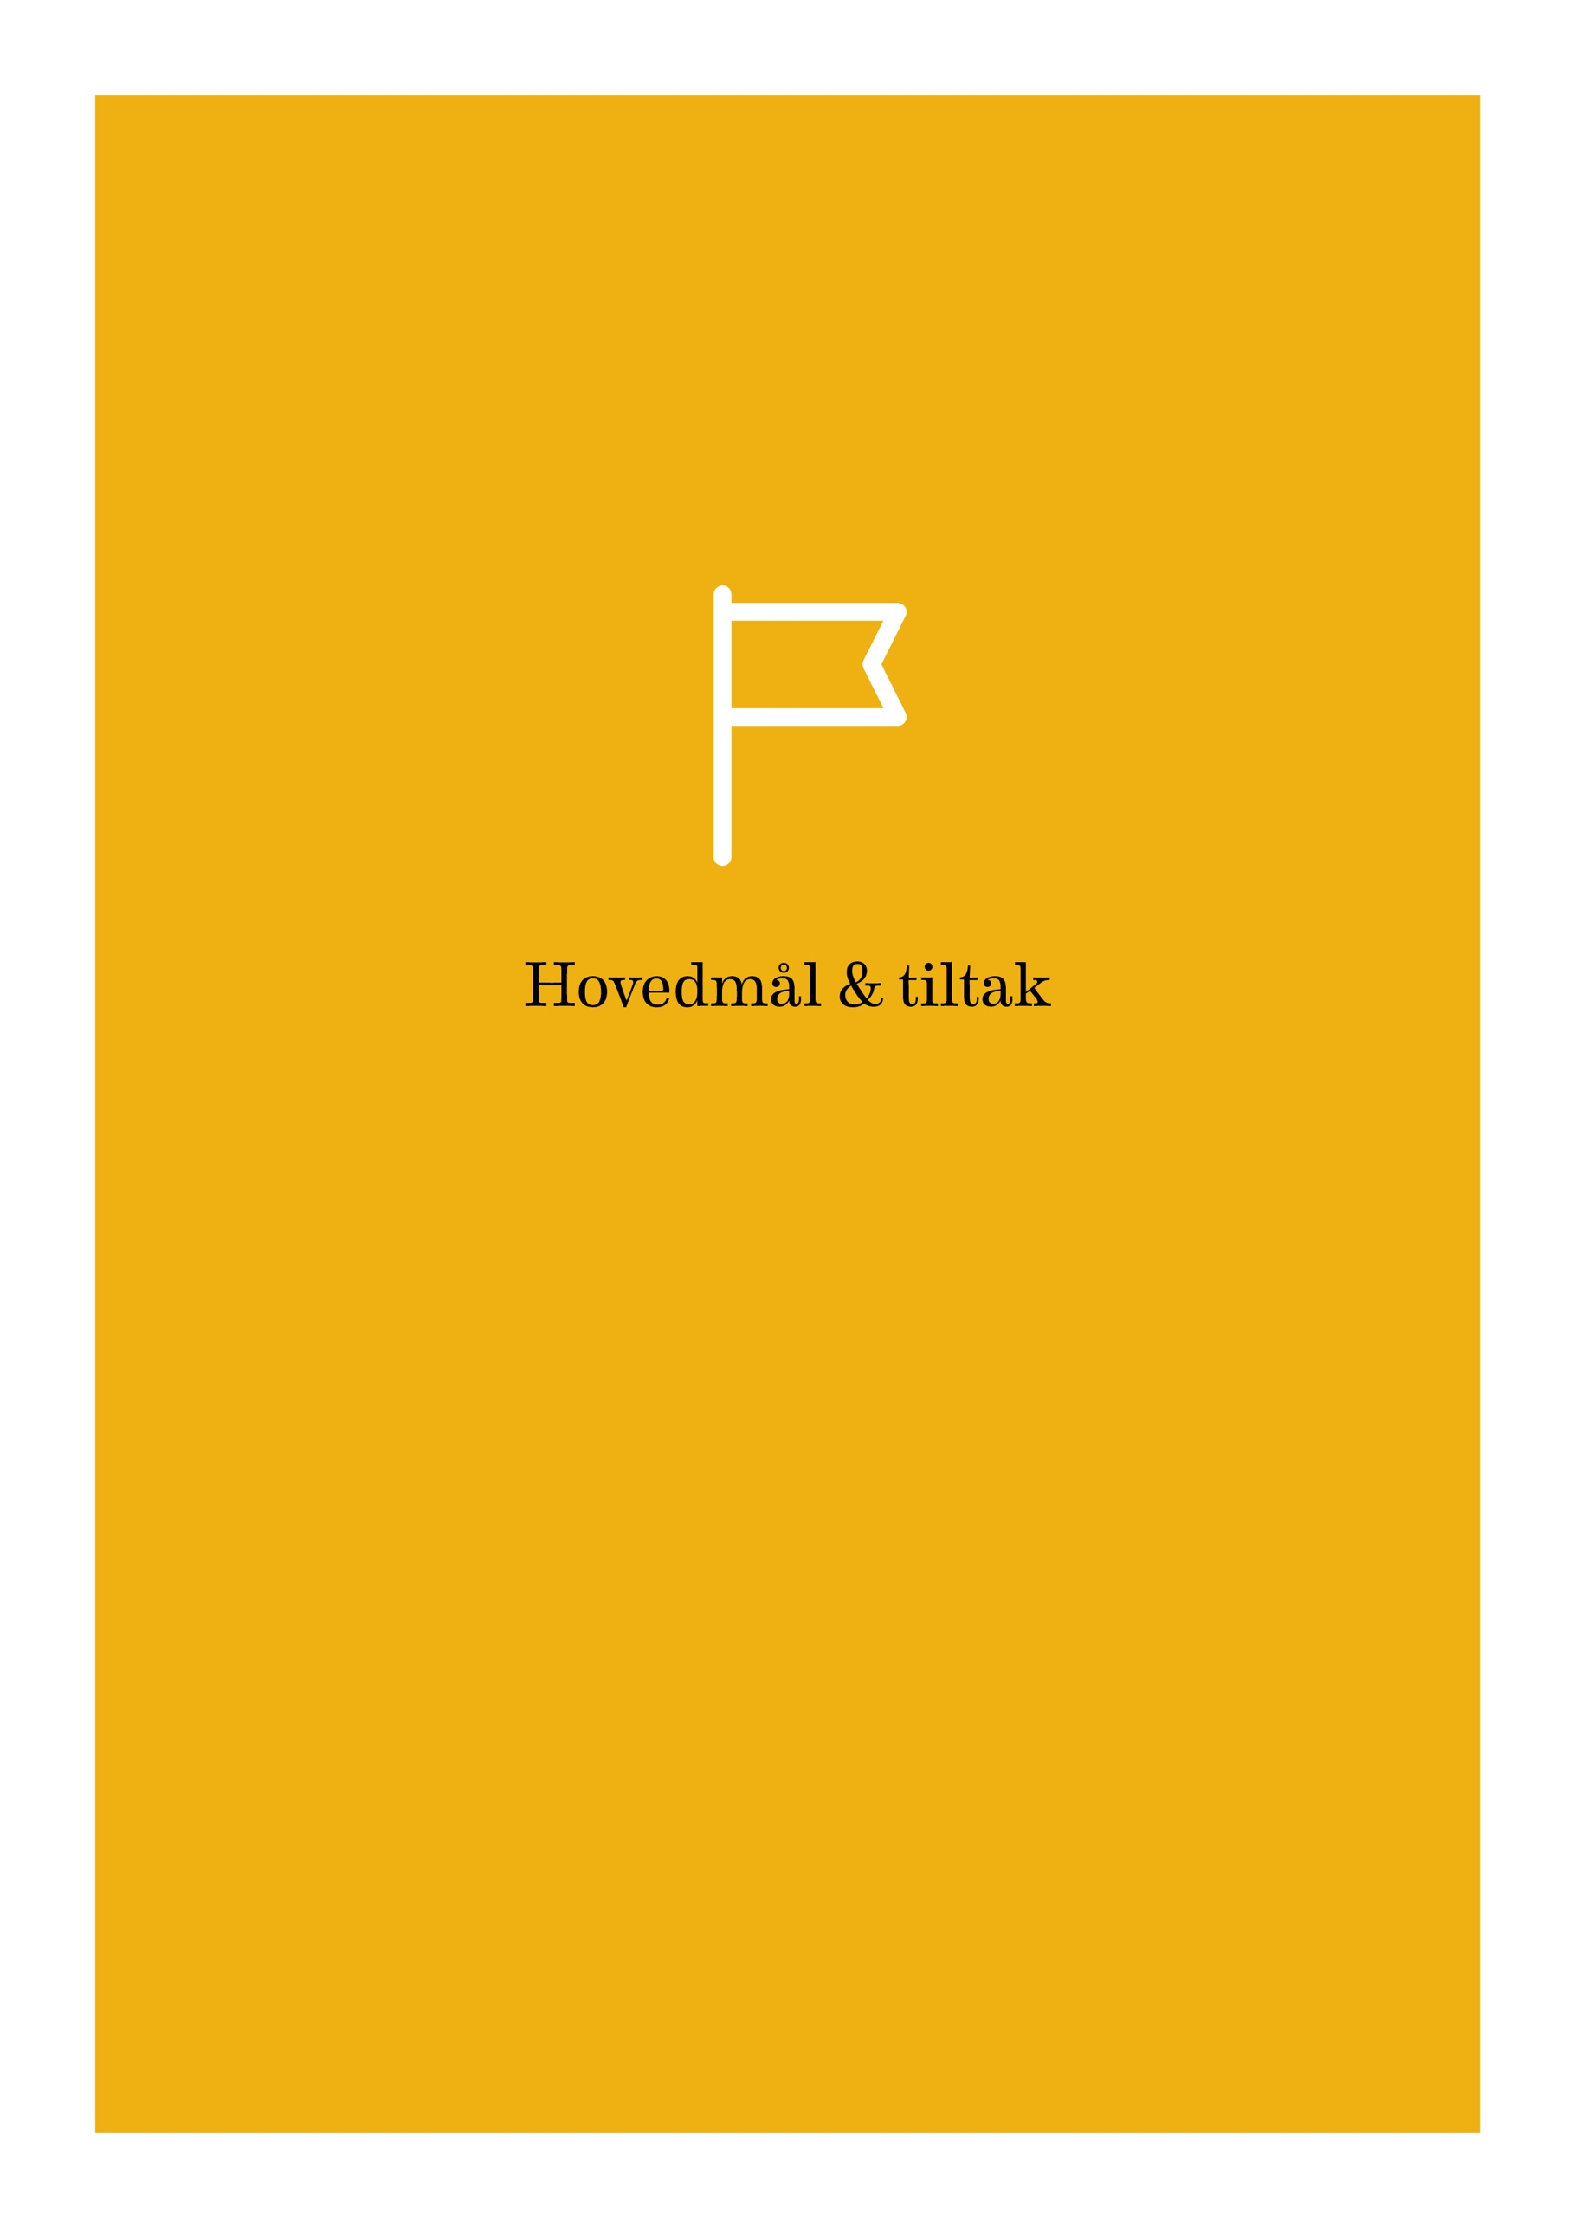

Objectives and measures for the coming period (2017–2019)

The proposed measures are not organised by grounds for discrimination, but divided into three activity areas. The reason for this is that diversity measures should be an integral part of the institution's structures and management rather than a discrete part, which would entail a risk of becoming a lower priority. This approach, known as the mainstreaming approach to organisational diversity work, is recommended by the Equality and Anti-discrimination Ombudsman, the body charged with supervising public bodies’ compliance with their duty to actively promote equality. Diversity mainstreaming represents an approach whereby an organisation’s diversity efforts form an integral part of its strategy, governance, structure and management. However, mainstreaming is not effective without institutionalisation, concrete strategies and assignment of responsibility. This emerged in the then Equality Commission’s two reports from 2011 and 2012 (Official Norwegian Reports NOU 2012:15 – Policy for Equality/NOU 2011:18 – Structure for Equality). The action plan below as adopted by the Board shall therefore oblige the institution to apply a diversity policy where responsibility is not diffused, but assigned, and where concrete measures are to be implemented by a stipulated deadline.
It is a challenge to formulate proposed measures that on the one hand must not be too detailed and specific and on the other hand not so general that they become difficult to operationalise and thus become less binding. The measures listed below are an attempt to balance overall guidelines against the concrete level. Some measures are more comprehensive than others, but they are not listed in order of priority, as the proposal is to adopt the action plan in its entirety. The measures are divided into three levels:

- Institution level – organisation and management
Main goal: HiOA’s core value diversity shall be an integral part of the institution's culture, structure and management.

- Faculty and centre level – research and education
Main goal: The faculties shall apply an effective local diversity policy, and relevant diversity perspectives shall be integrated into research and development.

- Recruitment and development
Main goal: HiOA’s recruitment and career development processes shall be characterised by equal opportunities. Career and competence development measures shall contribute to raising the organisation's diversity competence.

- Institution level – organisation and management
Main goal: HiOA’s core value diversity shall be an integral part of the institution's culture, structure and management.
Goals | Measures | Responsibility | Deadline
- HiOA's core value diversity shall be an integral part of Strategy 2024 in order to ensure continued strategic support for diversity efforts | HR director/diversity officer/the diversity committee will contribute to the strategy development process | Director of the Department of Organisation and Corporate Governance (ORV) | Spring 2017
- Diversity work shall be established as a fixed item on the HR budget to ensure that the results of different diversity projects can be monitored and measured | Diversity activities shall be included as a fixed checkpoint in the (annual) HR budget process and in long-term planning | HR Director | Autumn 2017/ongoing
- Diversity work shall confer merit and be highlighted in joint events for all staff/students in order to emphasise that HiOA shall have an organisational culture and a working and study environment characterised by diversity | Diversity prizes shall be established. These prizes shall be awarded to students and staff who have initiated measures or activities to promote diversity at HiOA. Criteria for awarding these prizes must be established. | Programme director for culture, diversity and welfare (staff)/Pro-Rector Education (students) | Start-up 2017, to be awarded annually
- The diversity competence of the HiOA managers shall be raised to enable them to translate the core value diversity into practical management and governance | The programme for diversity management in the university, university college and institute sector shall be developed further and fully integrated in management development | Programme directors for leadership development and for culture, diversity and welfare, respectively | 31 Dec. 2017
- HiOA shall be established as an arena for the exchange of knowledge and experience of diversity in Norwegian academia in order to be a driving force in exploring what the expanded equality concept will mean to the sector | Examples of measures:  - HiOA will host the national networking conference for diversity in the university and university college sector in 2017  - A diversity management programme shall be offered to the whole university, university college and institute sector | Rector/diversity officer/resource group for the programme for diversity management in the university, university college and institute sector | Ongoing

- Faculty and centre level – research and education
Main goal: The faculties shall apply an effective local diversity policy, and relevant diversity perspectives shall be integrated into research and development.
Goals | Measures | Responsibility | Deadline
- The work to promote diversity and prevent discrimination shall be systematised at faculty and centre level to ensure that measures are expedient in the existing situation | Local action plans for diversity shall be prepared and implemented that address the duty to actively promote equality’s focus on gender, ethnicity and functional impairment as grounds for discrimination. The central HR department will prepare a common template and toolbox with research-based proposals for measures. The local action plans shall be linked to the central action plan. | Deans/heads of centres/HR director | To be completed by 1 Aug. 2018  To be implemented by 31 Dec. 2019
- HiOA’s teaching activities and teaching material shall be universally designed to ensure that everyone has equal access to education | Training in universal ICT design shall be developed further and made available through the HiOA Academy. The Department of Computer Science can be a resource to draw on in the work to meet the statutory requirements for universal design in ICT solutions in the university and university college sector by 2021. | Pro-Rector Education | 31 Dec. 2019
- The reason for the low proportion of immigrants among researchers and academic staff and TA staff with higher education at HiOA shall be mapped with a view to developing measures to increase it | Internal funds shall be announced for a research project to culminate in concrete measures to promote ethnic diversity at HiOA. Expert environments at all faculties and centres can apply. NIFU's diversity statistics are used as the basis for comparing the development with other universities and university colleges. | Pro-rector for R&D | 1 Aug. 2018
- Through their studies, HiOA students shall develop critical, intersectional diversity competence of relevance to their respective subject areas and subsequent areas of work | The academic content of study programmes shall be reviewed to ensure this. Training in how to conduct ‘diversity reviews’ of study programmes is provided through the heads of department forum and/or the HiOA Academy. | Heads of department | From 1 Jan. 2018

- Recruitment and development
Main goal: HiOA’s recruitment and career development processes shall be characterised by equal opportunities. Career and competence development measures shall contribute to raising the organisation's diversity competence.
Goals | Measures | Responsibility | Deadline
- The HiOA Academy shall further develop its strategic focus on diversity and offer all employees diversity competence based on requirements and needs | The present diversity course portfolio shall be reviewed/expanded and reorganised based on different groups of employees’ knowledge and competence needs. It should be considered whether parts of the training should be made compulsory. | HR director/project manager for the HiOA Academy | Ongoing
- HiOA shall encourage an increase in the proportion of immigrants in top academic positions. | Twenty-five per cent of participants in HiOA’s mentoring programme for candidates for promotion to top academic positions shall come from immigrant backgrounds. All TR positions must be advertised internationally with a requirement for Scandinavian language qualifications to be acquired within three years. | Pro-rector for R&D | From 2018
- HiOA shall contribute to and make use of research-based diversity recruitment | HiOA as case institution in a Nordic study of recruitment practices in higher education funded by Nordforsk and led by the Institute for Social Research (ISF) | HR director/expanded recruitment team | 31 Dec. 2019
- HiOA’s new managers shall bring experience and knowledge of the field of diversity and equality into the organisation to ensure that the organisation can ‘reap the benefits of diversity’ (Strategy 2020) | Competence in and experience of diversity and equality work shall be emphasised in recruitment for managerial positions. The content of the term diversity competence must be defined. | Managers/recruiters/HR | Formal practice from 1 Jan. 2018, then ongoing
- HiOA shall have good gender balance in all job categories (as a rule, a maximum range of 60/40). | HiOA’s expanded recruitment team, managers, assessment and appointments committees are to be trained in recruitment for equality, and gender balance is established as a fixed checkpoint in the recruitment process. Training under the auspices of the HiOA Academy | Head of HiOA’s expanded recruitment team and programme director for leadership development | Ongoing

New Knowledge, New Practice, Strategy 2020 for Oslo and Akershus University College of Applied Sciences. A new strategy for the institution, Strategy 2024, is under development, and one of the measures proposed in this plan is to ensure continued support for diversity efforts in the new strategy.
This expansion of focus from gender to diversity corresponds to the 2014 expansion of the remit of the Committee for Gender Balance and Diversity in Research (Kif), which the Ministry of Education and Research expanded to include ethnic diversity as well as gender.
Public bodies have an obligation to make active, targeted and systematic efforts to promote equality and prevent discrimination on grounds of gender, ethnicity and functional impairment (the duty to actively promote equality). Moreover, the Act relating to a prohibition against discrimination on the basis of sexual orientation, gender identity and gender expression came into force on 1 January 2014. Public enterprises must also make active and targeted efforts to promote universal design. The reporting obligation is fulfilled through HiOA’s annual report. The duty to actively promote equality and the reporting obligations are based on the Gender Equality Act, the Anti-discrimination Act and the Anti-discrimination and Accessibility Act.
Source: Database for Statistics on Higher Education (DBH).
There has been a marginal decrease in the proportion of women in top academic positions compared with 2015. The development is being monitored in order to distinguish development trends from minor natural fluctuations.
The equal pay provision, cf. the Gender Equality Act Section 5.
The diversity statistics provide an overview of immigrants and descendants of immigrants among researchers and academic staff and technical and administrative staff with higher education in Norwegian research and higher education in the years 2007, 2010 and 2014.
The proportion of immigrants in the population as a whole was 16% in 2014.
Statistics Norway's 2016 population projections show that the number of immigrants and Norwegian-born persons with immigrant parents will increase significantly over the next decades.
Statistics Norway report 2016/33.
Planned measures implemented in 2016 include establishing voice announcement in the elevators in SG26, installing six new induction loop systems in classrooms and purchasing three mobile systems, and moving card readers in P48 to the right height and distance from the doors. Future plans include automatic door openers for some disabled toilets.
People from immigrant backgrounds includes both 'immigrants', people with two foreign-born parents who have immigrated themselves, and 'Norwegian-born persons to immigrant parents', i.e. people who were born and grew up in Norway who have two foreign-born parents.

